**ROAD ACCIDENT REPORTS – SQL QUERIES**

**CY_Casualties:**

**SELECT SUM(number_of_casualties) AS CY_casualties**

**FROM road_accident**

**WHERE YEAR(accident_date) = '2022';**

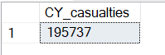

--------------------------------------------------------------------------------------

**CY – Accidents - 2022:**

**SELECT COUNT(DISTINCT accident_index) as CY_Accidents**

**FROM road_accident**

**WHERE YEAR(accident_date) = '2022';**

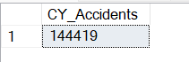

--------------------------------------------------------------------------------------

**CY – Fatal Casualties - 2022:**

**SELECT SUM(number_of_casualties) AS CY_Fatal_Accidents**

**FROM road_accident**

**WHERE accident_severity = 'Fatal' AND YEAR(accident_date) = '2022';**

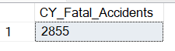

--------------------------------------------------------------------------------------

**CY – Serios Casualties -2022:**

**SELECT SUM(number_of_casualties) AS CY_Serios_Accidents**

**FROM road_accident**

**WHERE accident_severity = 'Serious' AND YEAR(accident_date) = '2022';**

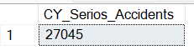

--------------------------------------------------------------------------------------

**CY – Slight Casualties – 2022:**

**SELECT SUM(number_of_casualties) AS CY_Slight_Accidents**

**FROM road_accident**

**WHERE accident_severity = 'Slight' AND YEAR(accident_date) = '2022';**

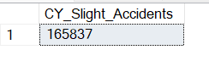

**Total Number of [Slight, Fatal, Serious] Casualties:**

**with slight_casualties AS (**

**SELECT SUM(number_of_casualties) as CY_Slight**

**FROM road_accident**

**WHERE accident_severity = 'Slight'**

**),**

**Fatal_casualties AS (**

**SELECT SUM(number_of_casualties) as CY_Fatal**

**FROM road_accident**

**WHERE accident_severity = 'Fatal'**

**),**

**Serious_casualties AS (**

**SELECT SUM(number_of_casualties) as CY_Serious**

**FROM road_accident**

**WHERE accident_severity = 'Serious'**

**)**

**SELECT * FROM slight_casualties,Fatal_casualties,Serious_casualties;**

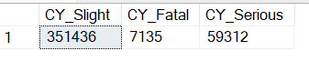

--------------------------------------------------------------------------------------

**Percentage(%) of Accidents that got Severity - Slight:**

**SELECT CAST(SUM(number_of_casualties) AS DECIMAL(10,2))/**

**(SELECT(CAST(SUM(number_of_casualties) AS DECIMAL(10,2))) FROM road_accident) AS "Slight Severity-Percentage(%)"**

**FROM road_accident**

**WHERE accident_severity = 'Slight';**

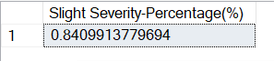

--------------------------------------------------------------------------------------

**Percentage(%) of Accidents that got Severity – Fatal:**

**SELECT CAST(SUM(number_of_casualties) AS DECIMAL(10,2))/**

**(SELECT(CAST(SUM(number_of_casualties) AS DECIMAL(10,2))) FROM road_accident) AS "Fatal-Severity-Percentage(%)"**

**FROM road_accident**

**WHERE accident_severity = 'Fatal';**

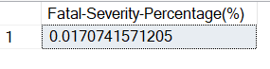

--------------------------------------------------------------------------------------

**Percentage(%) of Accidents that got Severity – Serious:**

**SELECT CAST(SUM(number_of_casualties) AS DECIMAL(10,2))/**

**(SELECT(CAST(SUM(number_of_casualties) AS DECIMAL(10,2))) FROM road_accident) AS "Serious-Severity-Percentage(%)"**

**FROM road_accident**

**WHERE accident_severity = 'Serious';**

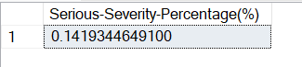

**---------------------------------------------------------------------------------------------------------**

**Vehicle Group – Total Number of Casualtiies:**

**SELECT**

**CASE**

**WHEN vehicle_type IN ('Agricultural vehicle') THEN 'Agricultural'**

**WHEN vehicle_type IN ('Car', 'Taxi/Private hire car') THEN 'Cars'**

**WHEN vehicle_type IN ('Motorcycle 125cc and under',**

**'Motorcycle over 125cc and up to 500cc',**

**'Motorcycle over 500cc',**

**'Motorcycle 50cc and under') THEN 'Bikes'**

**WHEN vehicle_type IN ('Bus or coach (17 or more pass seats)',**

**'Minibus (8 - 16 passenger seats)') THEN 'Bus'**

**WHEN vehicle_type IN ('Van / Goods 3.5 tonnes mgw or under',**

**'Goods over 3.5t. and under 7.5t',**

**'Goods 7.5 tonnes mgw and over') THEN 'Van'**

**ELSE 'Other'**

**END AS Vehicle_Group,**

**SUM(number_of_casualties) AS 'CY - Casualties'**

**FROM road_accident**

**WHERE YEAR(accident_date) = '2022'**

**GROUP BY**

**CASE**

**WHEN vehicle_type IN ('Agricultural vehicle') THEN 'Agricultural'**

**WHEN vehicle_type IN ('Car', 'Taxi/Private hire car') THEN 'Cars'**

**WHEN vehicle_type IN ('Motorcycle 125cc and under',**

**'Motorcycle over 125cc and up to 500cc',**

**'Motorcycle over 500cc',**

**'Motorcycle 50cc and under') THEN 'Bikes'**

**WHEN vehicle_type IN ('Bus or coach (17 or more pass seats)',**

**'Minibus (8 - 16 passenger seats)') THEN 'Bus'**

**WHEN vehicle_type IN ('Van / Goods 3.5 tonnes mgw or under',**

**'Goods over 3.5t. and under 7.5t',**

**'Goods 7.5 tonnes mgw and over') THEN 'Van'**

**ELSE 'Other'**

**END;**

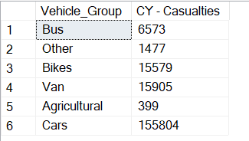

**CY – Casualties Monthly Trend:**

**SELECT DATENAME(MONTH, accident_date) AS 'Month Name',**

**SUM(number_of_casualties) AS 'CY - Casualties'**

**FROM road_accident**

**WHERE YEAR(accident_date) = '2022'**

**GROUP BY DATENAME(MONTH, accident_date);**

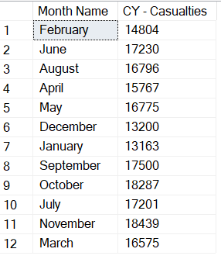

--------------------------------------------------------------------------------------

**Types of Road – Total Number of Casualties:**

**SELECT road_type, SUM(number_of_casualties) AS 'Total No Of Casualties'**

**FROM road_accident**

**WHERE YEAR(accident_date) = '2022'**

**GROUP BY road_type;**

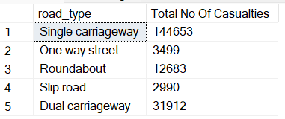

--------------------------------------------------------------------------------------

**Area – wise Percentage(%) and Total Number of Casualties:**

**SELECT urban_or_rural_area, SUM(number_of_casualties) AS 'Total Number of Casualties',**

**CAST(CAST(SUM(number_of_casualties) AS DECIMAL(10,2)) * 100 /**

**(SELECT CAST(SUM(number_of_casualties) AS DECIMAL(10,2))**

**FROM road_accident )AS DECIMAL(10,2)) AS '% of Casualties in Rural / Urban)'**

**FROM road_accident**

**-- WHERE YEAR(accident_date) = '2022'**

**GROUP BY urban_or_rural_area;**

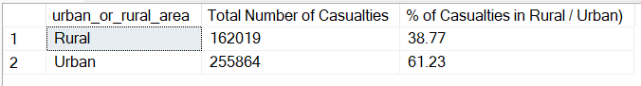

**Count of Casualties By Light Conditions:**

**SELECT light_conditions,**

**COUNT(*) as 'Count of Each Datas'**

**FROM road_accident**

**GROUP BY light_conditions;**

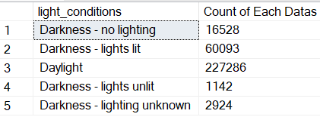

--------------------------------------------------------------------------------------

**Percentage (%) and Segregation of Casualties by Different Light Conditions:**

SELECT

CASE

WHEN light_conditions IN ('Daylight') THEN 'Day'

WHEN light_conditions IN ('Darkness - no lighting',

'Darkness - lights lit',

'Darkness - lights unlit',

'Darkness - lighting unknown') THEN 'Night'

END AS 'Light Condition',

CAST(CAST(SUM(number_of_casualties) AS DECIMAL(10,2)) * 100 /

(SELECT CAST(SUM(number_of_casualties) AS DECIMAL(10,2))

FROM road_accident

WHERE YEAR(accident_date) = '2022') AS DECIMAL(10,2)) AS CY_Casualties_PCT

FROM road_accident

WHERE YEAR(accident_date) = '2022'

GROUP BY

CASE

WHEN light_conditions IN ('Daylight') THEN 'Day'

WHEN light_conditions IN ('Darkness - no lighting',

'Darkness - lights lit',

'Darkness - lights unlit',

'Darkness - lighting unknown')

THEN 'Night'

END;

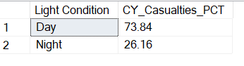

--------------------------------------------------------------------------------------

**Top 10 Local Authority with Highest Total Number of Casualties:**

**SELECT TOP 10 local_authority,**

**SUM(number_of_casualties) AS 'Total No Of Casualties'**

**FROM road_accident**

**GROUP BY local_authority**

**ORDER BY 'Total No of Casualties' DESC;**

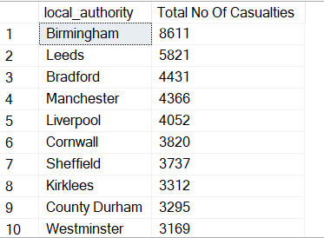

**--------------------------------------------------------------------------------------**

**PREPARED BY,**

**Johnson Paul D**